



# DEPARTAMENTO DE CIENCIAS DE LA COMPUTACIÓN INGENIERÍA EN SISTEMAS E INFORMÁTICA

***PROJECT “LIQUOR STORE AUTOMATION”***

## **MEMBERS:**

## PAREDES MEDRANO FERNANDO PATRICIO

## VELÁSTEGUI SOLÍS ALEX DARIO

## VENEGAS TORRES CAMILA VANESSA

## TOAPANTA FARINANGO WILSON DARIO

***Tutor(a):***

## Dr. Edison Lascano

*Sangolquí, June 24th, 2020*

### Introduction

### This document describes all the requirements for the design of software for a liquor store system. The software does not belong to any specific company or business. The specification has been structured based on the guidelines that have been given by the IEEE830 standard.

* 1. **Purpose**
* • The main objective is to define in a correct and concrete way the functional and non-functional requirements and thus be able to develop the new software for the liquor store services, validating through this document.
* The following software that is being developed belongs to the same team, so there are no requirements for the development of this program.
  1. **Scope**

The software due to all the features it presents and to which it is focused will be called "Liquor Store Automation".

Consider the following points in a more detailed way: Application by user console

* Enter to the system.
* Manage beverage code.
* Create Order.
* Register data for the Electronic Invoice.
* Confirm Order.

Console application for System Administrator.

* Enter to system.
* Review Order
* Check the electronic bill.
* Verify Data.
* View order location.
  1. Involved Staff

|  |  |  |
| --- | --- | --- |
| Name: | | Camila Venegas |
| Rol: | | Project leader, developer, tester. |
| Professional category: | | Software Engineering Student |
| Responsibilities: | | Developer |
| Contact information: | [cvvenegas@espe.edu.ec](mailto:cvvenegas@espe.edu.ec) | |
| Approval: | Yes | |

|  |  |  |
| --- | --- | --- |
| Name: | | Wilson Toapanta |
| Rol: | | Developer, verifier |
| Professional category: | | Software Engineering Student |
| Responsibilities: | | Code review, help and verify documentation work |
| Contact information: | [wdtoapanta3@espe.edu.ec](mailto:wdtoapanta3@espe.edu.ec) | |
| Approval: | Yes | |

|  |  |  |
| --- | --- | --- |
| Name: | | Alex Velástegui |
| Rol: | | Developer, verifier |
| Professional category: | | Software Engineering Student |
| Responsibilities: | | Code review, help and verify documentation work |
| Contact information: | [advelastegui1@espe.edu.ec](mailto:advelastegui1@espe.edu.ec) | |
| Approval: | Yes | |

|  |  |  |
| --- | --- | --- |
| Nombre: | | Fernando Paredes |
| Rol: | | Developer, verifier |
| Categoría Profesional: | | Software Engineering Student |
| Responsabilidades: | | Code review, help and verify documentation work |
| Contact information: | [fpparedes2@espe.edu.ec](mailto:fpparedes2@espe.edu.ec) | |
| Approval: | Yes | |

* 1. Definitions, acronyms and abbreviations

|  |  |
| --- | --- |
| Concept | Definition |
| System Administrator | Person in charge of orders. |

* 1. References

|  |  |  |  |  |
| --- | --- | --- | --- | --- |
| References | Title | Route | Date | Author |
| 1 | Standard IEEE 830 | PDF | 2008 | IEEE |
| 2 | Clean Code | PDF | 2008 | Robert C. Martin Series |
|  | | | | |

* 1. Summary

This document is divided into three sections.

In the first section, an introduction to this document is made and a vision of the functional and non-functional requirements of the software, the scope, as well as a description of each of the people involved in the development and creation of the software.

In the second section, a general description of the software will be made, in order to present the main functions that it will have to perform, the restrictions, its characteristics, factors, and the dependencies that affect the software development procedure.

And in the third section of this document, all the functional and non-functional requirements that the system must have are defined in detail.

1. General Description
   1. Product Perspective

"Liquor Store Manager" is a software which focuses on the sale of liquors, snacks and combos or promotions, to people over 18 who want to buy at home faster and easier. The respective menu will specify the type, brand, size and price, based on this the consumer will be able to create an order based on the stock that the local has. You can also add snacks such as french fries, peanuts and chewing gum. The software is also included with a combos section in which specific drinks and snacks will be included where there will be a decrease in the price. After placing the order, the consumer will choose their method of payment by card or cash. Next you will have to fill out an Electronic Invoice in which you will put your name, email address, ID and age. When filling in the pre-established data, the total price will be displayed and an option will appear where the program will request an approval in which the order will have to be confirmed or rejected. After confirming the order the consumer would have completed his order.

* 1. Product functionality

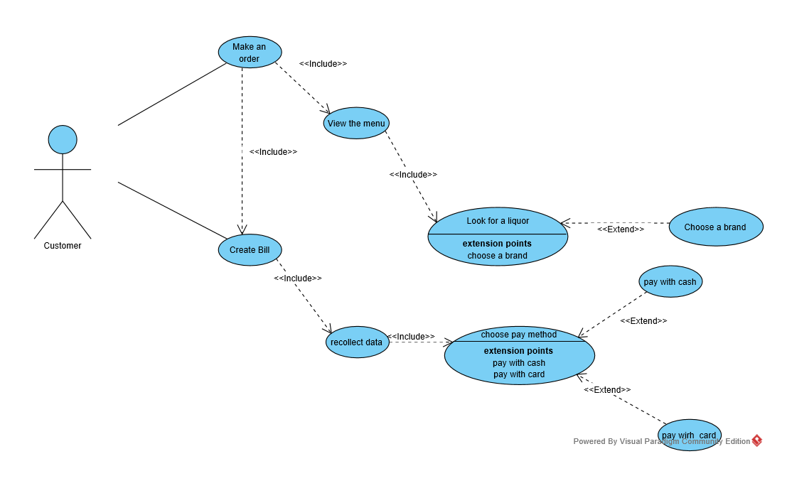

* 1. User characteristics

|  |  |
| --- | --- |
| User Type | User |
| Academic training | Basic Education |
| Habilities | Program management |
| Activities | Manage beverage code, create order, record data for electronic invoice |

|  |  |
| --- | --- |
| User Type | System Administrator |
| Academic training | Basic Education |
| Habilities | Program management |
| Activities | Review Order, Review Electronic Invoice, Verify Data, Verify order location |

* 1. Restrictions

• The software must be developed in the Java Netbeans programming language.

• The information of the Electronic Invoice will be stored in an ArrayList.

• The software will be consumer friendly giving various indications to be simple when using it.

• The program should be as clear as possible and should not be flawed when compiling.

• The program can only be used on a desktop or laptop computer.

• The program must have a simple design and implementation, easy to manage and compile.

• After having made the Electronic Invoice the program will ask for a confirmation of your order.

* 1. Assumptions and dependencies

• At the moment the program will only work through the Netbeans console.

• The user has the basic knowledge to manipulate a desktop or laptop computer.

• The requirements described in the document are functional for the execution of the software.

• A correct execution and management of the program by the user is requested.

* 1. Evolución previsible del sistema

In the next software updates, a more user-friendly and specific graphical interface will be implemented, as well as new types of files where the program information will be saved.

1. Specific Requirements
   1. Functional Requirements

Liquor Store Automation

1. The program must allow entry the orders

The entry is made through the orders that the user will request

The order will take the data of drink, snack or in turn combo

1. The options that were chosen in the order should be showed on the screen

User data entry

The entry is made by keyboard

User data will help fill out the invoice

1. The program must provide the cost of every product added in the order
2. The program must confirm the orden before pay for the bevergaes, snacks or combos.
3. Create a bill in which the order data will be placed, and customer
4. The registration of the new customer must be seen on the screen, which will be added later to the invoice.
   1. Non-functional Requirements
5. The application must allow the user to interact with the order entry and personal data entry interface for the bill.
6. The program must allow the user to enter the client's personal data when placing the order.
7. The program must provide an understandable invoice with data entered by the user
8. The program must have a running time of no more than 5 seconds.
9. The program must show the menus that are in the system
10. Use Case Diagrams



1. Specification Use Cases

|  |  |
| --- | --- |
| Identifier | RF1 |
| Name | Make the order |
| Description | The user must make a selection of a beverage and some snacks |
| Actors | User |
| Preconditions | Have money |
| Postconditions | The user will be in the menu choosing what to order |
| Normal flow of events | |
| 1. Open the system. 2. View the menu. 3. Choose the products you want to order. 4. Make the order. | |
| Alternate flows and exceptions | |
| 1. Enter negative numbers 2. The program should show an error message | |
| 1. Enter a char 2. The program should show an error message | |

|  |  |
| --- | --- |
| Identifier | RF2 |
| Name | Show order |
| Description | The user will be able to visualize the brand, price, size of the drinks, and the quantity of snacks. |
| Actors | User |
| Preconditions | Have money |
| Postconditions | The user has the prices of his order |
| Normal flow of events | |
| 1. View the menu 2. Select order. 3. View prices. | |
| Alternate flows and exceptions | |
| 1. Enter negative numbers 2. The program should show an error message | |
| 1. Enter a char 2. The program should show an error message | |

|  |  |
| --- | --- |
| Identifier | RF3 |
| Name | Provide Products |
| Description | The user will be able to visualize the price of the drinks, and snacks. |
| Actors | User |
| Preconditions | Have money |
| Postconditions | The user has the prices of his order |
| Normal flow of events | |
| 1. Select order. 2. View product. | |
| Alternate flows and exceptions | |
| 1. Enter negative numbers 2. The program should show an error message | |
| 1. Enter a char 2. The program should show an error message | |

|  |  |
| --- | --- |
| Identifier | RF4 |
| Name | Confirm order |
| Description | The user must press 1 if he wants to confirm and 0 if he wants to cancel the order. |
| Actors | User |
| Preconditions | Have money, Create an order |
| Postconditions |  |
| Normal flow of events | |
| 1. Select Products. 2. Show Products. 3. Show Prices. 4. Confirm Order or Cancel Order. | |
| Alternate flows and exceptions | |
| 1. Enter negative numbers 2. The program should show an error message | |
| 1. Enter a char 2. The program should show an error message | |

|  |  |
| --- | --- |
| Identifier | RF5 |
| Name | Enter to the first menu |
| Description | The user enter to the program to make an order |
| Actors | User |
| Preconditions | Have money, Create an order |
| Postconditions |  |
| Normal flow of events | |
| 1. Open the program. 2. Show the menú . 3. Select an option. 4. Enter to the order menu. | |
| Alternate flows and exceptions | |
| 1. Enter negative numbers 2. The program should show an error message | |
| 1. Enter a char 2. The program should show an error message | |

|  |  |
| --- | --- |
| Identifier | RF6 |
| Name | Enter the customer data |
| Description | The user must save the data of the clients |
| Actors | User |
| Preconditions |  |
| Postconditions | Show the data on the bill |
| Normal flow of events | |
| 1. Enter to the program. 2. Confirm to add the new client 3. Select the option create a new client. 4. Enter the data of the client | |
| Alternate flows and exceptions | |
| 1. Enter negative numbers 2. The program should show an error message | |
| 1. Enter a char 2. The program should show an error message | |

6. Specification Use Cases

